Forecast Reliability Analysis in Electricity Demand Forecasting

CIND820 - Big Data Analytics Project
Student Name: Sadaf Hina
Student ID: 501406183
Instructor: Prof. Ceni Babaoglu
Date: 4/19/2026

Abstract
This study investigates the reliability of electricity demand forecasting by analyzing when forecasting models fail rather than focusing solely on overall accuracy. Using the PJM hourly electricity demand dataset, a lag-1 persistence model is implemented as a baseline forecasting approach. Forecast errors are quantified using Mean Absolute Error (MAE) and analyzed across temporal dimensions such as hour of day, day of week, season, and demand regimes.
Statistical validation further confirmed these differences, with ANOVA results showing significant variation in forecast error across seasons (F = 2220.62, p < 0.001) and demand regimes (F = 694.21, p = 8.66 × 10⁻³⁰¹).

Introduction
Electricity demand forecasting is essential for maintaining grid stability and optimizing energy production. Accurate forecasts help prevent overproduction and shortages. (Hyndman & Athanasopoulos, 2021)
However, most research focuses only on accuracy metrics, ignoring when models fail.

Problem:
Forecasting models may perform well overall but fail during:
- Peak demand
- Seasonal extremes
- Operational stress conditions

Objective:
This project shifts focus to:
“Forecast reliability instead of just accuracy”
While previous forecasting research has primarily focused on improving predictive accuracy, fewer studies have examined the reliability of forecasts under varying operational conditions. Prior work in electricity demand forecasting has shown that performance deteriorates under volatile conditions and structural variation, particularly during seasonal peaks and demand extremes (Hyndman & Athanasopoulos, 2021; Hong & Fan, 2016). This study therefore shifts the focus from average accuracy to condition-based reliability.

Research Questions
This study addresses the following research questions:
- How does forecast error vary across temporal dimensions such as hour of day, day of week, and season?
- Are forecast errors significantly higher during high-demand periods?
- Does forecasting reliability deteriorate under seasonal extremes?

Dataset Description
The main variable used in this analysis is `PJME_MW`, representing electricity load in megawatts.
- Dataset: PJM Hourly Energy Consumption
- Source: Kaggle
- Frequency: Hourly
- Observations: ~145,000
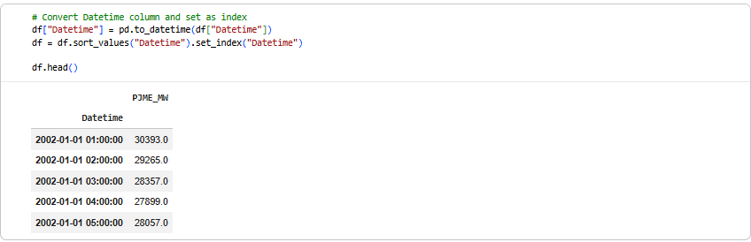

Variables:
- Target: PJME_MW
- Derived:
  - Hour
  - Day of week
  - Month
  - Season
  - Demand category
  - Absolute error
“The PJM dataset contains approximately 145,000 hourly observations of electricity demand and spans multiple years of system activity. After loading the dataset, the Datetime column was converted into datetime format and used as the index to support time-series processing and feature extraction.”

Data Preparation Explanation
The Datetime column is converted into a proper datetime format and used as the index to support time-series analysis. This allows time-based features such as hour, weekday, and season to be extracted accurately.

Forecast Construction
A lag-1 persistence model is used as a transparent baseline forecast. In this model, each predicted value is simply the previous hour's actual demand. Absolute forecast error is then computed to measure how far the forecast deviates from the actual value
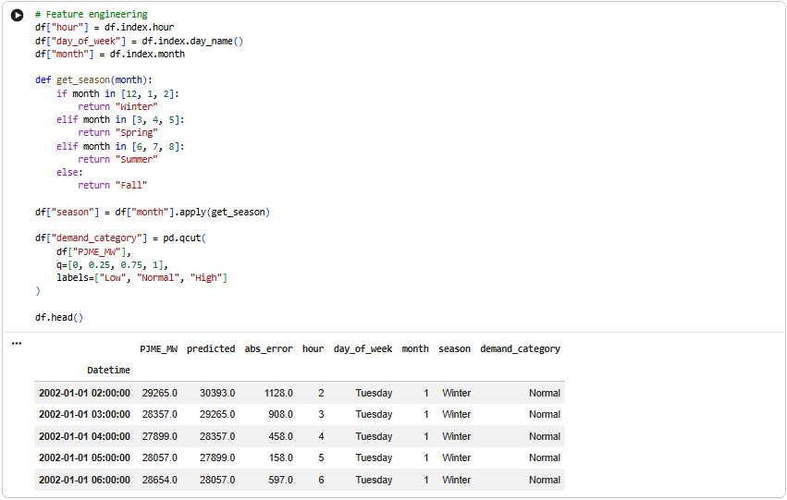

Methodology

Forecasting Model
The baseline forecasting model used in this study is the lag-1 persistence model, defined as:
ŷₜ = yₜ₋₁
where ŷₜ is the predicted demand at time t and yₜ₋₁ is the actual demand at time t−1. This model assumes that the best estimate of the next hour’s demand is the most recent observed value.

Error Measurement
To evaluate forecasting performance, Absolute Error (AE) was computed as:
AEₜ = |yₜ − ŷₜ|
For example, using the dataset values shown in the notebook, when the actual demand is 29,265 MW and the predicted demand is 30,393 MW, the absolute error is:
AE = |29,265 − 30,393| = 1,128 MW
A second example is:
AE = |28,357 − 29,265| = 908 MW
These numbers come directly from your notebook output.

Mean Absolute Error (MAE)
“Overall forecasting performance was evaluated using Mean Absolute Error (MAE), defined as:
MAE = (1/n) Σ |yₜ − ŷₜ|
MAE measures the average magnitude of forecast error in megawatts and was chosen because it is interpretable, robust to extreme outliers relative to squared-error measures, and suitable for comparing reliability across groups.(Hyndman & Athanasopoulos, 2021).

Feature Engineering
To analyze how forecasting errors vary across conditions, several features were extracted from the datetime index:
- Hour of day (0–23)
- Day of week
- Month
- Season, defined as:
  - Winter: December–February
  - Spring: March–May
  - Summer: June–August
  - Fall: September–November
Additionally, demand was categorized into three regimes using quantiles:
- Low demand
- Normal demand
- High demand
These engineered features made it possible to compare model reliability across structured operational conditions rather than relying only on a single aggregate performance value.

Statistical Validation

ANOVA Test
To determine whether forecasting errors differ significantly across groups, a one-way Analysis of Variance (ANOVA) test was conducted.
$$F=\frac{\text{Variance Between Groups}}{\text{Variance Within Groups}}$$
A high F-statistic indicates that group means differ significantly relative to within-group variability.

Seasonal Analysis
ANOVA was applied to compare forecast errors across seasons.
Results:
- F-statistic = 2220.62
- p-value p < 0.001
Since the p-value is significantly less than 0.05, the null hypothesis is rejected. This indicates that forecast errors differ significantly across seasons.

Demand Regime Analysis
ANOVA was also applied to compare forecast errors across demand categories.
Results:
- F-statistic = 694.21
- p-value = 8.66 × 10⁻³⁰¹
These results confirm that forecast errors vary significantly across demand levels.

Interpretation of Statistical Results
The statistical analysis demonstrates that forecast errors are not uniformly distributed across different conditions. Instead, they are strongly influenced by:
- Seasonal variations
- Demand intensity
This confirms that forecasting reliability depends on external system conditions rather than remaining constant over time.

Results & Analysis
Forecast errors vary substantially across hours of the day. Higher error values are observed during peak demand periods such as early morning and late evening. This suggests that rapid shifts in electricity usage make forecasting more difficult during these hours.

Error by Hour of Day
Figure 1 shows mean absolute forecast error by hour of day. Forecast errors vary substantially across intraday intervals, with higher values observed during early morning and late evening hours. These periods correspond to times when electricity demand changes rapidly, making it more difficult for the lag-1 model to capture current conditions accurately. In contrast, midday hours show relatively lower errors, suggesting more stable demand behavior.
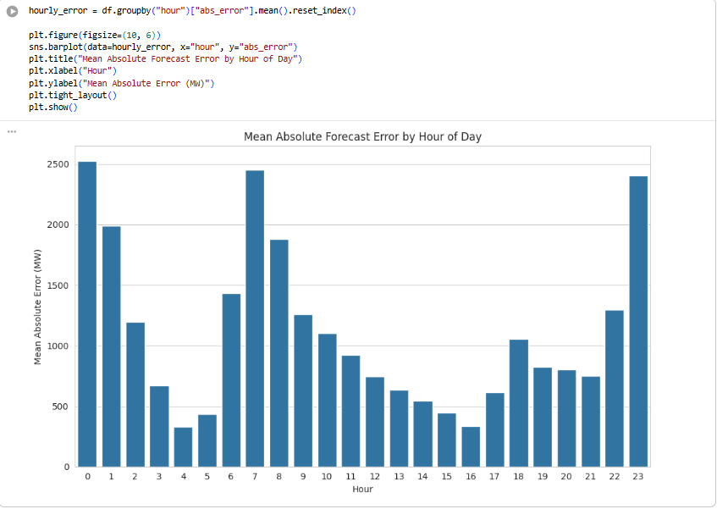
Figure 1. Mean Absolute Forecast Error by Hour of Day
Highest error at:
  - Early morning (0–2)
  - Peak hours (7–9)
  - Late night (23)
Lowest error during midday
The analysis of forecast error by day of the week reveals clear variability in model performance across different days. The results show that forecast errors are generally lower during weekends, particularly on Saturday and Sunday, compared to weekdays. In contrast, weekdays such as Tuesday and Wednesday exhibit higher error values.
This pattern can be explained by differences in electricity consumption behavior. Weekday demand is typically influenced by industrial and commercial activities, which introduce higher variability and unpredictability. On the other hand, weekend demand is more stable and residential-driven, making it easier for the lag-1 model to capture patterns. This demonstrates that forecasting accuracy is not uniform across the week and depends on underlying demand dynamics.

Error by Day of Week
Figure 2 presents mean absolute forecast error by day of the week. Forecast errors are generally lower on weekends and higher on weekdays, particularly around Tuesday and Wednesday. This likely reflects the greater variability introduced by industrial and commercial activity during business days. The result indicates that weekly consumption structure meaningfully affects forecast reliability.”
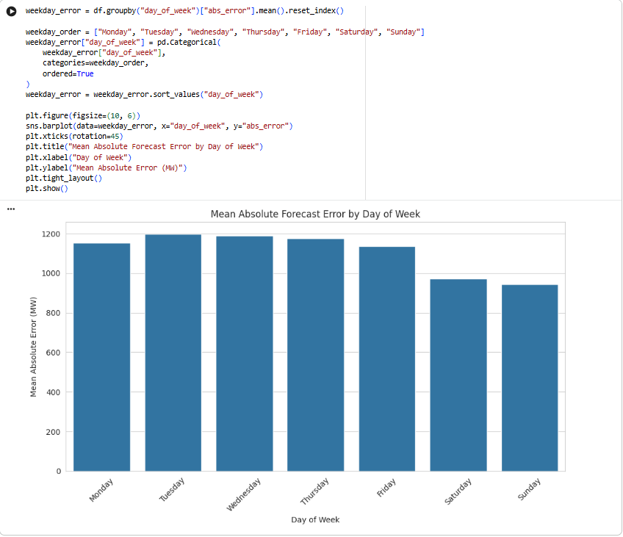
Figure 2. Mean Absolute Forecast Error by Day of Week
Higher error: Tuesday, Wednesday
Lower error: Weekend
Forecast errors vary across days of the week, indicating that electricity demand behavior is not constant throughout the week. Weekdays generally show slightly higher error levels, likely due to increased industrial and commercial activity. This suggests that weekly demand structure affects forecast reliability.

Error by Season
Figure 3 shows that forecast errors differ significantly across seasons. Summer exhibits the highest error, while spring has the lowest. This seasonal variation is likely driven by weather-sensitive electricity demand, especially increased cooling load during summer months. The result indicates that seasonal conditions are a major determinant of forecasting reliability.
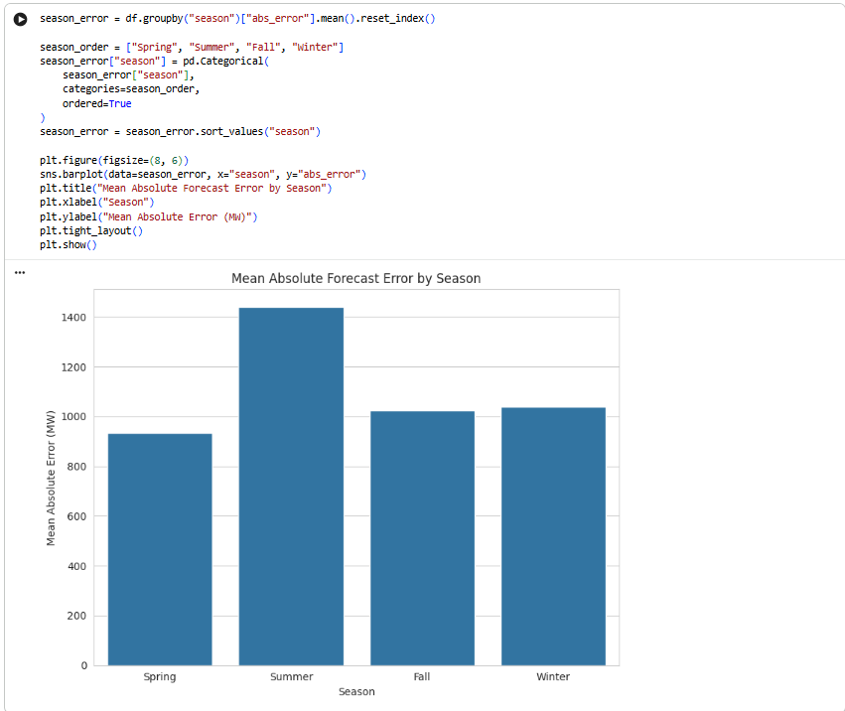
Figure 3. Mean Absolute Forecast Error by Season
Highest: Summer
Lowest: Spring Interpretation:
The seasonal analysis indicates significant differences in forecast error across seasons. The highest errors are observed during the summer season, while spring exhibits the lowest error levels. Fall and winter show moderate error values.
The increased error during summer can be attributed to high electricity demand driven by cooling needs, such as air conditioning usage. These demand spikes are often abrupt and difficult to predict using a simple lag-based model. In contrast, spring typically experiences milder weather conditions and more stable demand patterns, resulting in lower forecast errors.
These findings confirm that seasonal factors play a critical role in forecasting reliability and highlight the limitations of simple models under extreme conditions.

Error by Demand Regime
Figure 4 illustrates a clear increasing pattern in forecast error as demand moves from low to normal to high levels. The highest error occurs in the high-demand regime, indicating that the lag-1 model becomes less reliable during system stress. This finding is particularly important because high-demand conditions are also the periods of greatest operational risk.
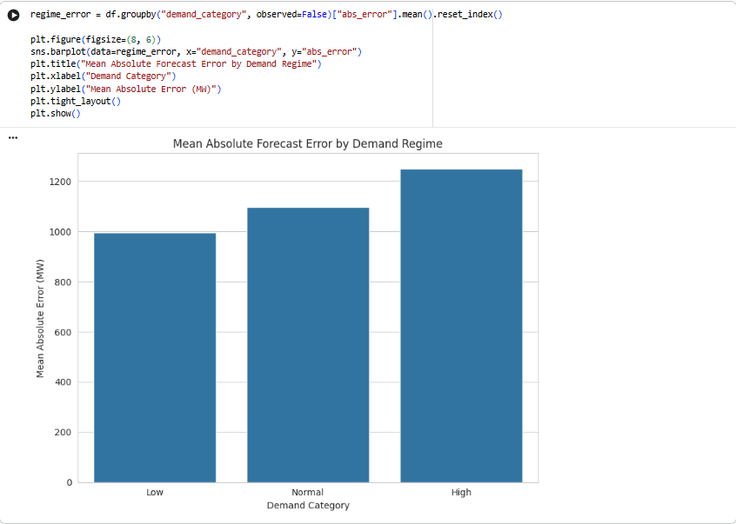
Figure 4. Mean Absolute Forecast Error by Demand Regime
The analysis of forecast error across demand regimes shows a clear increasing trend. Forecast errors are lowest in the low-demand category, increase in the normal-demand category, and are highest in the high-demand category.
This trend indicates that forecasting becomes more challenging as system demand increases. High-demand conditions are often associated with extreme weather events or peak consumption periods, which introduce greater variability and uncertainty. As a result, the lag-1 model, which assumes continuity from previous values, fails to accurately capture sudden spikes in demand.
This finding highlights a critical limitation of simple forecasting models and emphasizes the need for more advanced techniques under high-demand conditions.

Statistical Validation (ANOVA Results)
To verify whether the observed differences in forecast error are statistically meaningful, one-way ANOVA was applied. The ANOVA test compares between-group variance with within-group variance using the F-statistic.
For seasonal groups, the test produced:
- F-statistic = 2220.62
- p-value < 0.001
For demand regime groups, the test produced:
- F-statistic = 694.21
- p-value = 8.66 × 10⁻³⁰¹
Since both p-values are far below 0.05, the null hypothesis of equal mean forecast errors across groups is rejected. These results confirm that forecast reliability differs significantly across both seasons and demand regimes.”

ANOVA Results
Although ANOVA assumes independence of observations, which is partially violated in time-series data, it is used here as an approximate statistical validation tool. The consistency of the results across visual analysis and grouped error trends strengthens the credibility of the findings.

Electricity Demand Over Time
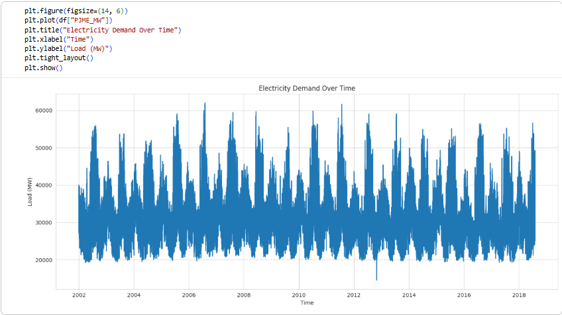

Discussion
The results of this study clearly demonstrate that electricity demand forecasting is not uniformly reliable across all conditions. While the lag-1 persistence model provides a simple and interpretable baseline, its performance varies significantly depending on temporal and operational factors. This indicates that forecasting accuracy is highly context-dependent, rather than consistent across the dataset.
A key finding is that forecast error is strongly influenced by time-based variables, including hour of the day, day of the week, and season. Higher errors observed during peak hours suggest that rapid changes in electricity consumption are difficult for simple models to capture. Similarly, weekday patterns exhibit higher variability compared to weekends, reflecting the influence of industrial and commercial activities.
Seasonal variation further reinforces this conclusion. The significantly higher errors observed during summer indicate that extreme demand conditions, driven by cooling requirements, introduce volatility that reduces model performance. In contrast, more stable conditions during spring correspond to lower forecasting errors.
Another important observation is the relationship between demand intensity and forecasting performance. As demand increases, forecast error also increases. High-demand conditions introduce nonlinear patterns and sudden spikes, which cannot be adequately captured by a lag-based model. This confirms that model performance deteriorates under system stress.
Overall, the study identifies several high-risk conditions where forecasting reliability is significantly reduced, including:
- Peak demand hours
- Summer season
- High-demand regimes
These findings emphasize the importance of evaluating forecasting models beyond average accuracy and considering their performance under critical conditions. (Hong & Fan, 2016).

Model Evaluation

Effectiveness:
MAE used correctly
Error trends identified
The effectiveness of the model was evaluated using Mean Absolute Error (MAE), which is an appropriate metric for measuring forecast accuracy in continuous data. MAE provides a clear interpretation of the average magnitude of prediction errors without being overly sensitive to extreme values. Through this metric, the study successfully identified systematic error patterns across different time and demand categories. The model effectively highlights when forecasting performs well and when it deteriorates, fulfilling the objective of analyzing forecast reliability.

Computational Efficiency:
The lag-1 persistence model used in this study is computationally efficient and requires minimal processing resources. Since it relies only on the previous observation to generate predictions, it does not involve complex training procedures or parameter tuning. This simplicity makes it an excellent baseline model for benchmarking more advanced forecasting techniques. However, this efficiency comes at the cost of limited predictive capability.

Stability Across Conditions:
Despite its simplicity, the model lacks stability across varying conditions. The results show significant fluctuations in error depending on time, season, and demand level. This indicates that the model does not generalize well across different scenarios and fails to maintain consistent performance. Therefore, it cannot be considered robust for real-world forecasting applications where demand patterns are dynamic and complex.

Limitations
1 This study has several important limitations that should be considered when interpreting the results.
First, the analysis relies on a lag-1 persistence model, which serves as a simple baseline forecasting approach. While this model is useful for understanding fundamental forecasting behavior, it is inherently limited in its ability to capture complex temporal dependencies and nonlinear patterns present in electricity demand data.
Second, the dataset does not incorporate external explanatory variables, such as weather conditions, economic activity, or population behavior. These factors are well-established drivers of electricity demand, particularly during periods of seasonal extremes. The absence of such variables restricts the model’s ability to fully explain variations in demand and contributes to reduced predictive accuracy.
Third, the study does not implement advanced forecasting techniques, including ARIMA models, gradient boosting methods, or neural networks. These approaches are capable of capturing more sophisticated relationships within the data and could potentially improve both accuracy and reliability compared to the baseline model.
Additionally, the modeling approach assumes a simple linear dependency structure, where current demand is primarily determined by the previous observation. This assumption oversimplifies real-world electricity consumption patterns, which are influenced by multiple interacting and often nonlinear factors.
Finally, the analysis does not incorporate formal model validation techniques, such as train-test splitting or cross-validation. As a result, the generalizability of the findings to unseen data cannot be fully assessed, which limits the robustness of the conclusions (Hyndman & Athanasopoulos, 2021).

Future Work
Future research can extend this study by incorporating more advanced modeling techniques and additional explanatory variables to improve forecasting accuracy and reliability.
One important enhancement is the integration of weather-related variables, such as temperature and humidity, which are known to have a strong influence on electricity demand patterns. Including these variables would allow the model to better capture seasonal effects and demand fluctuations driven by environmental conditions.
In terms of modeling approaches, future work should explore more sophisticated forecasting techniques, including ARIMA models for capturing temporal dependencies, XGBoost for modeling nonlinear relationships, and Long Short-Term Memory (LSTM) networks for learning long-term sequential patterns. These models have demonstrated strong performance in time-series forecasting and could provide improved predictive capability compared to the baseline lag-1 model.
A systematic comparative evaluation of multiple models under consistent conditions would provide deeper insights into their relative performance and robustness, particularly under high-demand and high-variability scenarios.
Additionally, future research should consider probabilistic forecasting methods, which generate prediction intervals rather than single-point estimates. This approach allows uncertainty to be quantified, which is critical for risk-aware decision-making in real-world energy systems.
Finally, implementing proper model validation techniques, such as train-test splitting and cross-validation, would improve the reliability and generalizability of results by ensuring that model performance is evaluated on unseen data.

Conclusion
This study demonstrates that forecast accuracy alone is insufficient for evaluating model performance. While the lag-1 model provides reasonable baseline predictions, its reliability varies significantly across different conditions.
The findings show that forecasting models are particularly vulnerable under:
- High-demand conditions
- Peak usage hours
- Seasonal extremes, especially during summer
These conditions introduce variability and volatility that simple models cannot capture effectively.
The results highlight the importance of evaluating forecasting models in terms of reliability under varying operational conditions, rather than relying solely on average error metrics.
From a practical perspective, these findings have important implications for real-world energy systems. Forecasting errors during critical periods can lead to inefficiencies, increased operational costs, and potential risks to grid stability.
In conclusion, this study emphasizes that understanding when models fail is just as important as measuring how accurate they are. Future forecasting approaches should focus on improving both accuracy and reliability to support robust and informed decision-making in the energy sector.
These findings reinforce the importance of developing forecasting models that are robust under high-variability conditions.

References
Hyndman, R. J., & Athanasopoulos, G. (2021).
Forecasting: Principles and practice (3rd ed.). OTexts.
https://otexts.com/fpp3/
Chen, T., & Guestrin, C. (2016).
XGBoost: A scalable tree boosting system. Proceedings of the 22nd ACM SIGKDD International Conference on Knowledge Discovery and Data Mining, 785–794.
https://doi.org/10.1145/2939672.2939785
(Open-access PDF: https://arxiv.org/abs/1603.02754)

Hong, T., & Fan, S. (2016).
Probabilistic electric load forecasting: A tutorial review. International Journal of Forecasting, 32(3), 914–938.
https://doi.org/10.1016/j.ijforecast.2015.11.011

Kong, W., Dong, Z. Y., Jia, Y., Hill, D. J., Xu, Y., & Zhang, Y. (2017).
Short-term residential load forecasting based on LSTM recurrent neural network. IEEE Transactions on Smart Grid, 10(1), 841–851.
https://doi.org/10.1109/TSG.2017.2753802
(Preprint version often available on IEEE Xplore or ResearchGate)

Taylor, J. W. (2003).
Short-term electricity demand forecasting using double seasonal exponential smoothing. Journal of the Operational Research Society, 54(8), 799–805.
https://doi.org/10.1057/palgrave.jors.2601589

Zhang, G., Patuwo, B. E., & Hu, M. Y. (1998).
Forecasting with artificial neural networks: The state of the art. International Journal of Forecasting, 14(1), 35–62.
https://doi.org/10.1016/S0169-2070(97)00044-7

